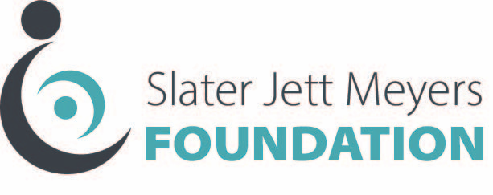

Indemnity Form

- It is understood that _____________________(Name of Organization) is requesting funding for the purchase of __________________________ (equipment/device). __________________________ (Name of Organization) has warranted to the Slater Jett Meyers Foundation that it has conducted all due diligence with respect to this device/equipment, that it is safe for its intended purposes, and that the device shall be used in accordance with the manufacturer’s specifications and guidelines.

- It is agreed that, in the event that any lawsuit arises out of the use and operation of the _______________________(equipment/device), and the Slater Jett Meyers Foundation or its officers are named as defendants in the lawsuit, _______________________(Name of Organization) shall hold harmless and indemnify the Slater Jett Meyers Foundation for any damages to person or property resulting from any cause whatsoever in nature, including the payment of attorneys’ fees, should the Slater Jett Meyers Foundation have need to retain counsel to defend itself in litigation or other court proceeding.

___________________________
(authorized signature)

___________________________
(position)

