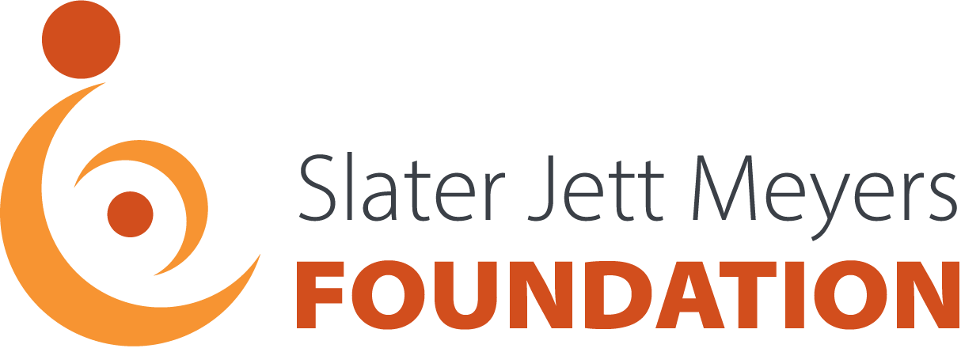

Fast Facts
About the SJM Foundation : The Slater Jett Meyers Foundation was established in 2002 as a non-profit 501(c)3 organization in memory of Slater Jett Meyers who passed away at 8 months due to complications which resulted from a birth injury. The Foundation is a volunteer organization with no administrative costs; 100% of the proceeds from fundraising are donated to organizations that work with birth injured children or individuals who have suffered a birth injury. We keep Slater’s memory alive and his legacy lives on through the children who benefit from the work of the SJM Foundation.
Mission: Provide comfort, assistance, advocacy and hope to birth injured children and young adults. We aspire to improve the quality of their lives, promote independence and enable mainstream integration by:
- Funding project specific programs with organizations that work with birth injured children and young adults, whose mission is closely aligned with the goals of the SJM Foundation.
- Donating the required equipment for these programs.
- Providing supplemental funding for alternative and complementary therapies for birth injured children.
- Educating families about the resources and funding available to optimize the care for their special needs child.
Vision: To become a dependable resource within the community that provides birth injured children and young adults with the supplemental services and funding necessary to live their lives to the fullest.
Fundraising: From 2002 thru 2019, the Slater Jett Meyers Foundation has hosted annual fundraising events. The Foundation has been able to provide the grants outlined in the “Giving” section below as a result of these fundraising efforts. Our goal is to expand our base of supporters by educating people about SJMF and encouraging them to get involved in their community. We work to retain our support by sharing our accomplishments, and continually striving to exceed the expectations of our supporters.
Giving: Some of the grants SJMF has provided are highlighted below.
Jawonio, Inc.:
- “Gait therapy” program to fulfill the dream of walking without assistance for hundreds of disabled children.
- “Multi-sensory” program. Sensory stimulation hastens recovery from brain injuries and other birth injuries.
- Therapeutic gym for infants and toddlers ages 2-3.
- Audio enhancement program at the new Early Childhood Center.
- Early Intervention playground renovation..

United Brachial Plexus Network: Provided matching funds for nationally broadcast, PBS “Spotlight On” documentary on awareness, causes and treatment of brachial plexus injuries.
Richmond Children’s Center:
- Therapeutic rehab equipment to support their mobility program.
- Sleep Safe systems to enhance the safety and quality of life.
- Multi-sensory playground at the Goldman House to enable the residents to enjoy time outside
Inspire of Orange County, NY: Provided adaptive equipment (Eyegaze System) to enable children with severe motor disabilities to use their retinas to communicate. In 2011 funded a swimming pool lift device to assist therapists.

SKIP of New York: From 2006 to 2011, provided funding for the Julia Fund which was established to support families in their quest to secure the services they need to care for their special needs children in the comfort of their own homes.

Dancing Dreams: Provided funding for DVDs for spring recital to give dancers a memory of their best day ever.

Life’s Journey: Hippotherapy program to provide therapy while enjoying the experience of horseback riding.

Venture: Multi-sensory room to enhance interaction with environment and hasten healing.

ARC of Rockland: Adaptive mobility equipment to enable therapists to work more effectively with the client.

