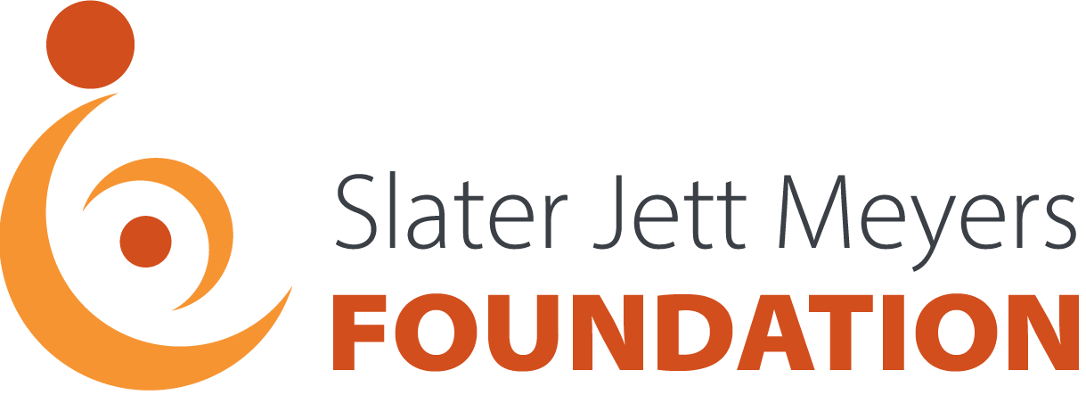

CHECK OUT THE VALUABLE RESOURCES ON THESE SITES BELOW:

- The Birth Injury Center connects families who have experienced a birth injury to pertinent information and resources.
https://birthinjurycenter.org

- The Cerebral Palsy Guide provides free educational materials, financial resources, and support options for families affected by this condition and other birth injuries.
https://www.cerebralpalsyguide.com

