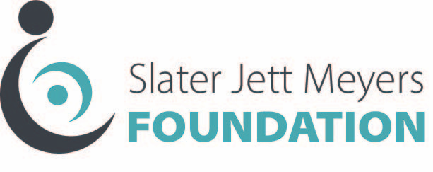

Funding Request Application

Guidelines for Consideration: All donations are awarded to not-for-profit organizations and must be used to assist individuals who have suffered a birth injury. Not all requests will receive funding due to budget limitations or inability to meet criteria.

Name of Organization:__________________________________________________
Address:____________________________________________________________
Phone:_____________________________Email:____________________________

Funding Request Amount:___________
Project/Program Description and Budget:

Statement of Need:

How will the project be evaluated?

__________________________________________________________________
The donation must be used for the purpose stated in the award letter and is considered restricted for that purpose. Direct contributions must be used within 12 months from receipt of funding. The undersigned agrees to these conditions:

Name of Applicant:___________________________________Date:______________
Signature of Applicant:___________________________________
Title of Applicant:_______________________________________
__________________________________________________________________
(below for SJM Foundation Use Only)
Date of Decision:_____________________Donation Request #:_________________
Approved or Denied?:
Reason for Decision: ____________________________________________________________________________________________________________________________________________________________

